**Algorithms**

A set of systematic instruction to be followed for a problem to be solved. A recipe to solve a problem. Mastering algorithm creation needs a lot of practice.

Algorithm to convert temperature from Celsius to Fahrenheit:

1. Input temperature in Celsius.
2. Multiply temperature by 9.
3. Divide result of step 2 by 5.
4. Add 32 to the result of step 3
5. Show results.

The program would be like:

*A = float(input("Please enter the temperature in Celsius: ")) #Step 1*

*B = A*9 #Step 2*

*C = B/5 #Step 3*

*D = C+32 #Step 4*

*print("The temperature in Fahrenheit is: ", D) #Step 5*

Python IDLE vs Shell vs Text Editor

**Identifiers vs Variables.**

Variables: Reserved locations to store values.

Identifier: Name given to variables, functions, objects etc

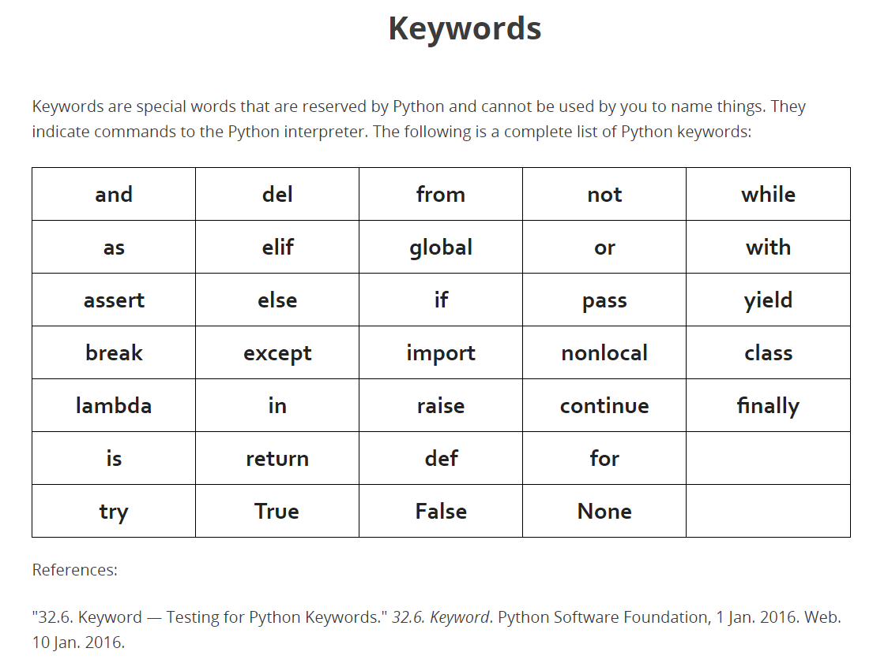

Variable Types

Basic variable types:

* Int (integer)
* Float (Floating point)
* Str (String)
* Bool (True or False)

To view variable type in python:

print(type(variable))

User Input:

* To get a user’s input the function used is input().

Rem: The input function always returns a string even if the user input is an integer.

Python Operators

* Unary

Works on one operand.

* Binary

Works on to operands

Symbols that tell the python interpreter to do some mathematical or logical operations.

Types of operators:

* Mathematical (+, -, *, /, **, %, //)
* Relational (<, <=, >, >=, !=, ==)
* Logical (or, and, not)
* Bitwise (|, &, ^, ~, <<, >>)
* Membership (in, not in)
* Identity (is, is not)

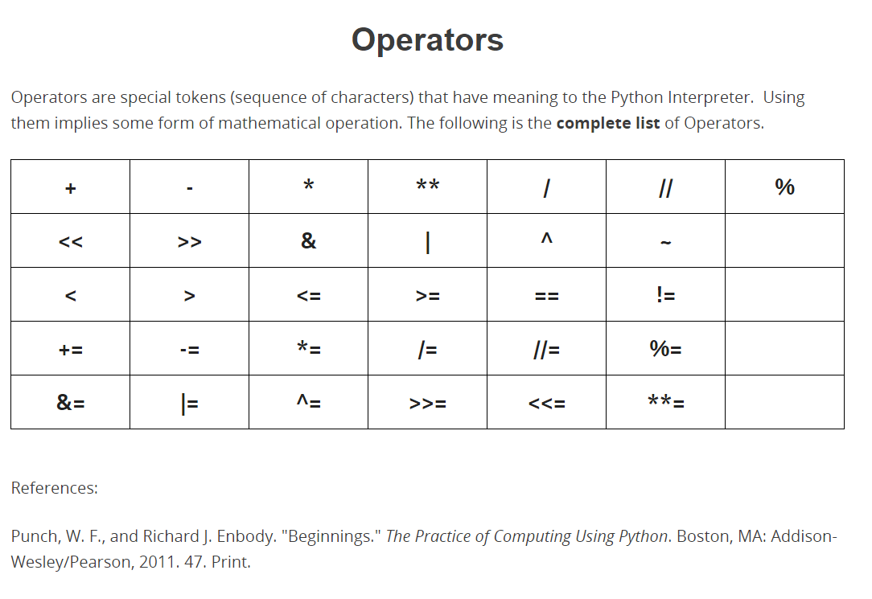

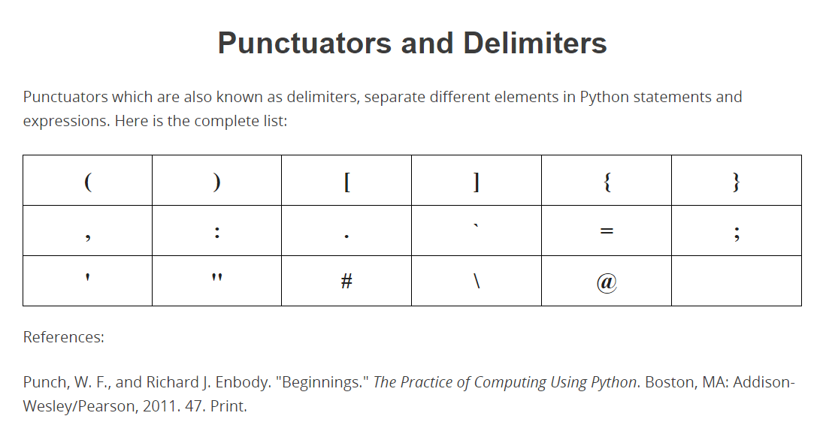

**Python Operators Precedence Table**

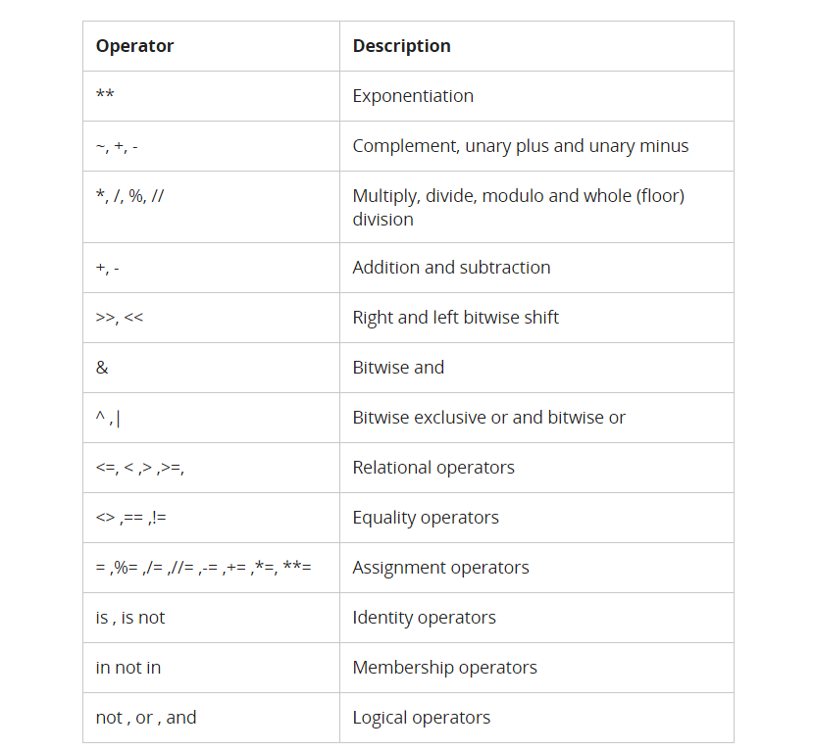

**Relational Operators**

AKA Comparison operators. Compares two operands with each other. Have lowere precedence than the arithmetic operators.

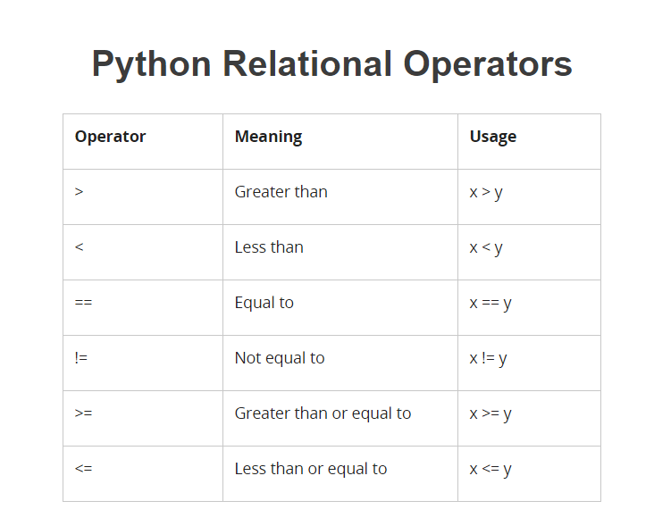

**Logical Operators**

True and True is True

True and False is False

False and False is False

Logical operators have the lowest precedence.

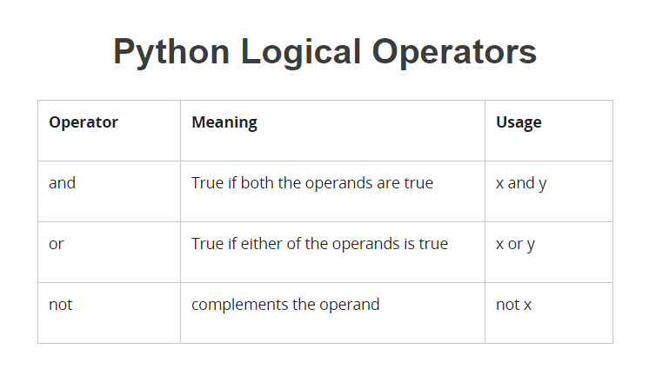

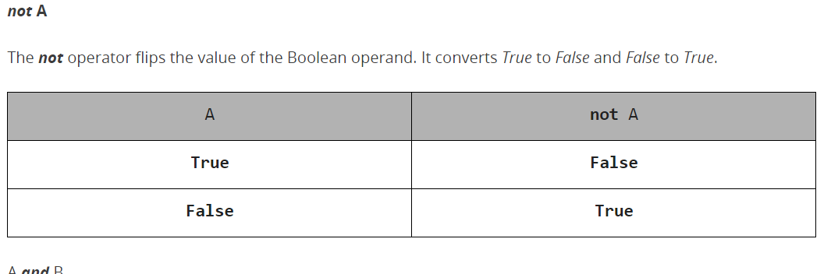

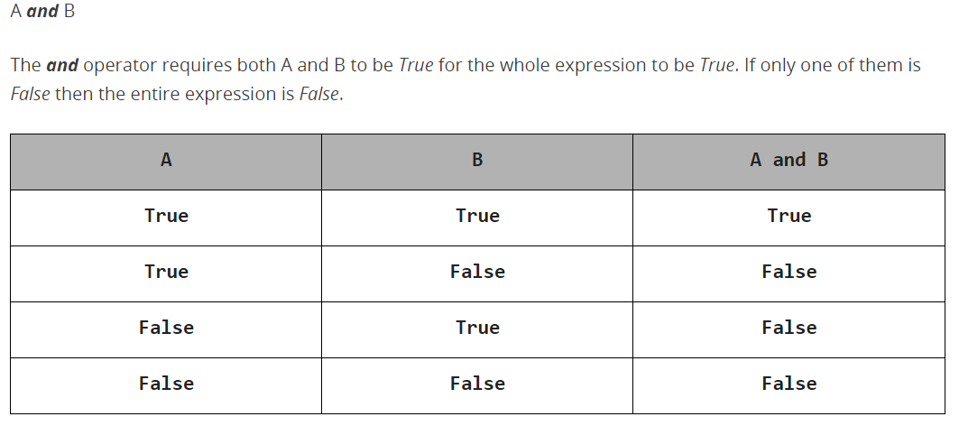

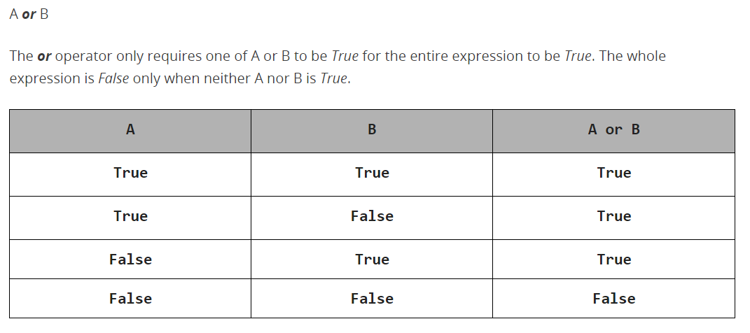

**Membership Operators**

